Name ________________________________ AP Calculus
Section 3.5 Derivatives of Trigonometric Functions

Show all your work!!

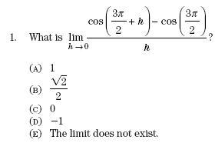

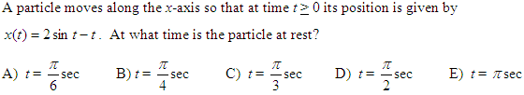
2.

3.

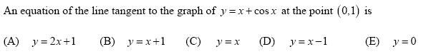
4.

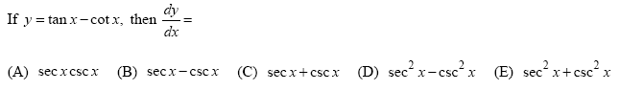
5.

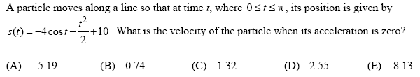
6.

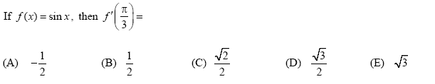
7.

